A resource

This is my fault. When I talk about “Peops “Stuff”…I mean just the stuff (not the peops). So, when I refer to a resource…it would simply be a cartoon image of a book. This would be used as decoration on a web site “Resource” page. I did not communicate this clearly.

Also true for the other Peops “Stuff”…so the Video…would look like an old fashioned reel-to-reel projector. And the Whirlwind tour…a caricature of a tornado. Make sense?

Facebook

I like it…but our Peops are “losing weight” I liked the tums in this picture… Could you put some more fat into their diet?

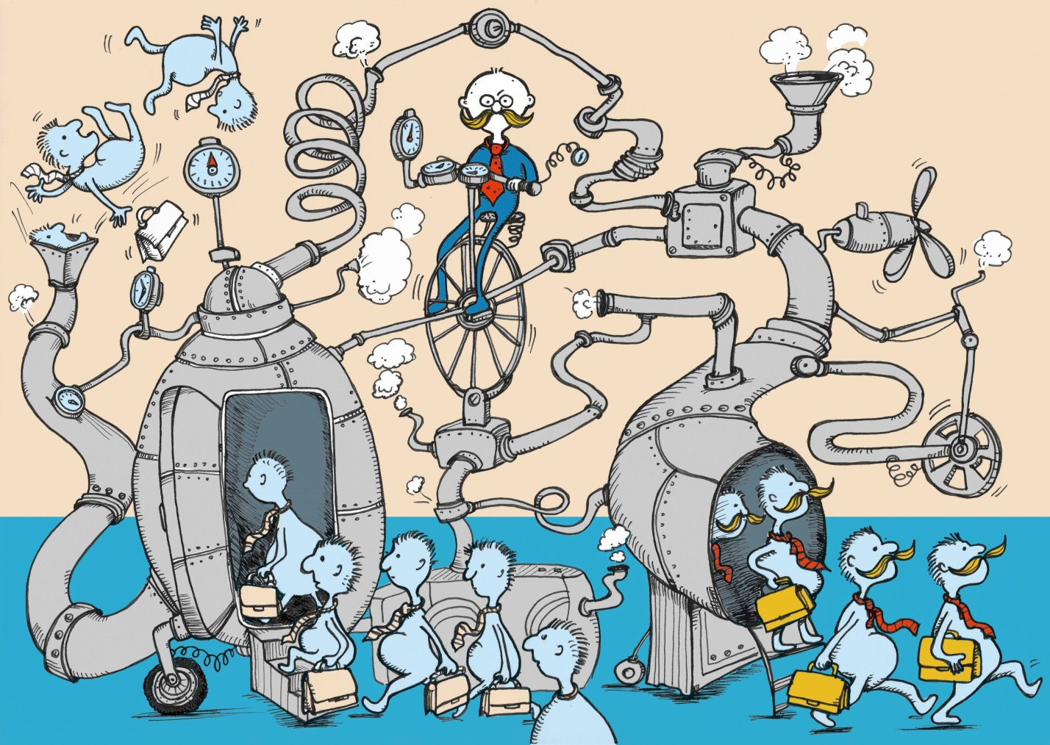

Looking Inquisitively…

More tum !

Manager looking Up.

I don’t know why…but it looks as though he’s looking straight ahead (but over his glasses)

Peops Milling Around.

Looks good!